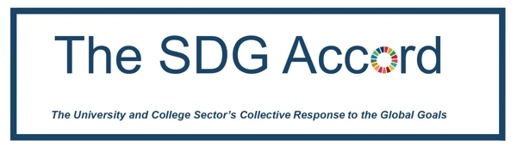

We recognise that as an SDG Accord signatory your institution has a greater story to tell regarding how SDGs are being integrated within your community, and as part of your institutional SDG Accord reporting, we are asking signatories to submit one or more case studies to share good practice, celebrate and/or outline barriers of how your institution is integrating the SDGs. The case studies will be shared publicly with fellow signatories and our Endorsing Network Partners and will be available on our website.

Please tick the relevant Case Study Themes your case study relates to:

Integration of SDGs in

☐ Institutional governance/strategic level
☐ SDGs in research
☐ SDGs in campus operations
☐ SDGs in curriculum development
☐ SDGs in student engagement activities
☐ SDGs into community activities
☐ SDGs at a whole-institution level

Focus on

☐ Goal 1 - No poverty
☐ Goal 2 - Zero hunger
☐ Goal 3 - Good health and wellbeing
☐ Goal 4 - Quality education
☐ Goal 5 - Gender equality
☐ Goal 6 - Clean water and sanitation
☐ Goal 7 - Affordable and clean energy
☐ Goal 8 - Decent work and economic growth
☐ Goal 9 - Industry, innovation and infrastructure
☐ Goal 10 - Reduced inequalities
☐ Goal 11 - Sustainable cities and communities
☐ Goal 12 - Responsible consumption and production
☐ Goal 13 - Climate action
☐ Goal 14 - Life below water
☐ Goal 15 - Life on land
☐ Goal 16 - Peace, justice and strong institutions
☐ Goal 17 - Partnerships for the goals

Please use this template for each of the SDG frameworks you wish to submit a case study for. We ask SDG Accord Signatories to submit at least one case study by 31st May each year to info@eauc.org.uk if you would like to have it included in the Annual SDG Accord Report. You can continue to provide case studies throughout the year and these will be added to the SDG Accord website.
Please submit case studies in English.
For each of the themes selected, please provide the relevant case study following the structure below:
EMAIL ADDRESS -
JOB TITLE -
NAME -
INSTITUTION NAME -

Describe briefly how the theme selected was implemented within your institution – max 300 words. Please include (if available) quotes from colleagues or others involved in the case study.
Summary:

Outline the 3 key benefits of integrating this theme:
1.
2.
3.

Outline the barriers or challenges encountered in integrating this theme and how you overcame these:
1.
2.
3.

Please outline your conclusions and recommendations to others (Max 200 words):

Include TWO images (max) that are relevant to your SDG case study – ONE should be your institutional logo. These will be used as part of your case study submission, so please ensure you have permission to use the images. Please add a brief description of the image.

Please submit your case study to info@eauc.org.uk

